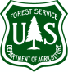 Plumas National Forest
In partnership with Plumas County Arts Commission

“Artist in Residence” 2024 Application

Name: _______________________________________________________________________________
Address: _____________________________________________________________________________
Phone number: ___________________________ Email address: ________________________________
Web site link: _________________________________________________________________________
In addition to this application form, the submission packet must include:
a cover letter, resume of art experience, and an electronic file or website link of artwork.
Literary samples should not exceed 10 pages.

Medium of Art and Description of Artwork: ___________________________________________________________________________________________________________________________________________________________________________________________________________________________________________________________________________________________________________________________________________________________________________________________________________________________________________________________________________________________________________________________________________________________________________________________________________________
What is your background in art?: ______________________________________________________________________________________________________________________________________________________________________________________________________________________________________________________________________________________________________________________________________________________________________________________________________________________________________________________________________________________________________________________________
Why do you want to participate in the Plumas National Forest Artist in Residence Program?
______________________________________________________________________________________________________________________________________________________________________________________________________________________________________________________________________________________________________________________________________________________________________________________________________________________________________________________________________________________________________________________________

You may add additional pages if you prefer, or if needed.

The dates for the 2024 Lookout stay are:
 August 19 to 22  September 16 to 19
Please check the date that works best for you.

Application Deadline is Friday, May 31st, 2023.

For visual artwork, artists are requested to make an appointment to deliver 2 original representative samples of your work to the Plumas Arts Gallery between Wednesday, May 25th and Friday, May 31st during gallery hours between 11am and 5pm. Call 530-283-3402 to make an appointment.

It is our intention to make decisions by May 15, 2023.

Mail this Application Package to:
Plumas Arts
P.O. Box 600
Quincy, CA 95971
Or email to: Gallery@plumasarts.org
For questions: email Gallery@plumasarts.org or call 530.283.3402

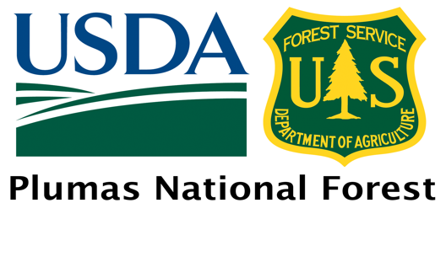
USDA is an equal opportunity provider, employer and lender
.

